STATE DIAGRAMS

STOCK MAINTANCE
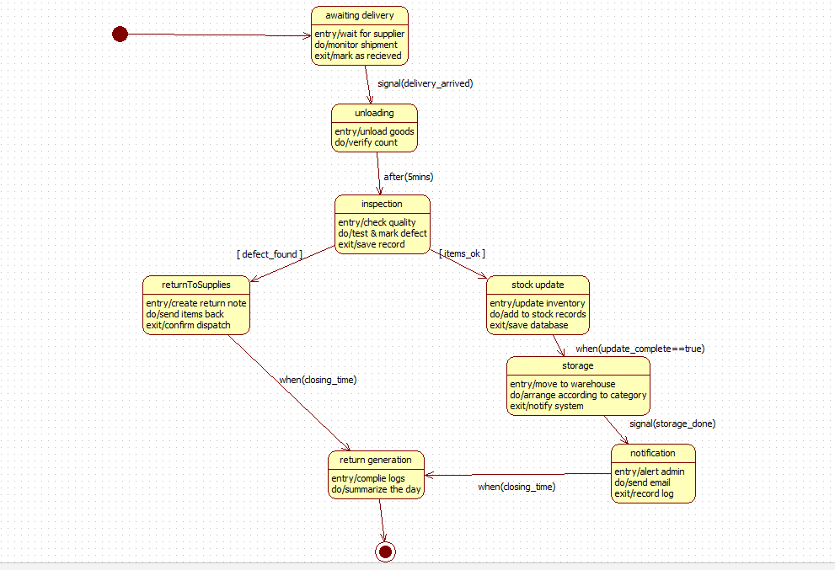

PASSPORT AUTHENTICATION
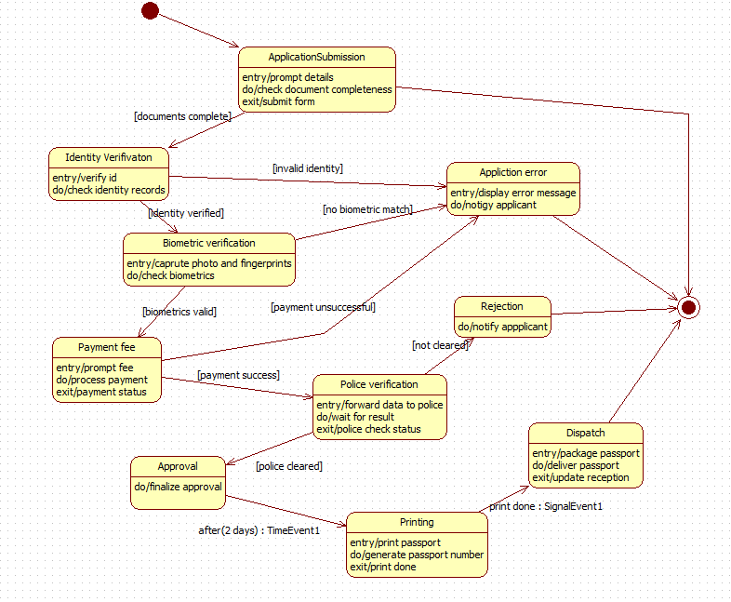

LIBRARY MANAGEMENT

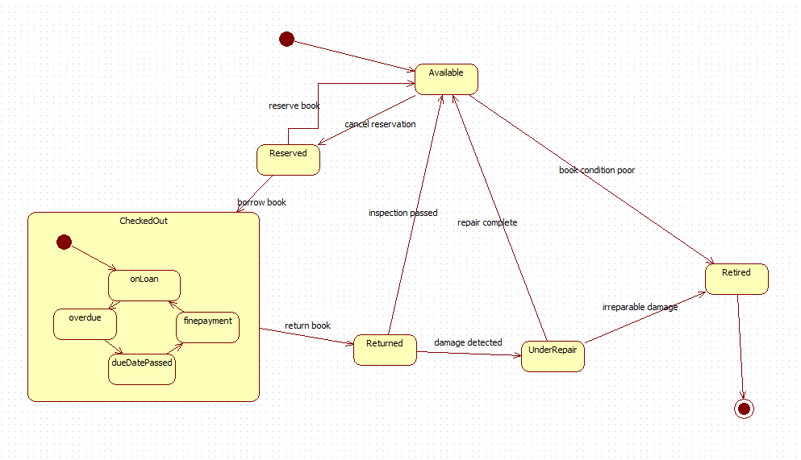

HOTEL MANAGEMENT

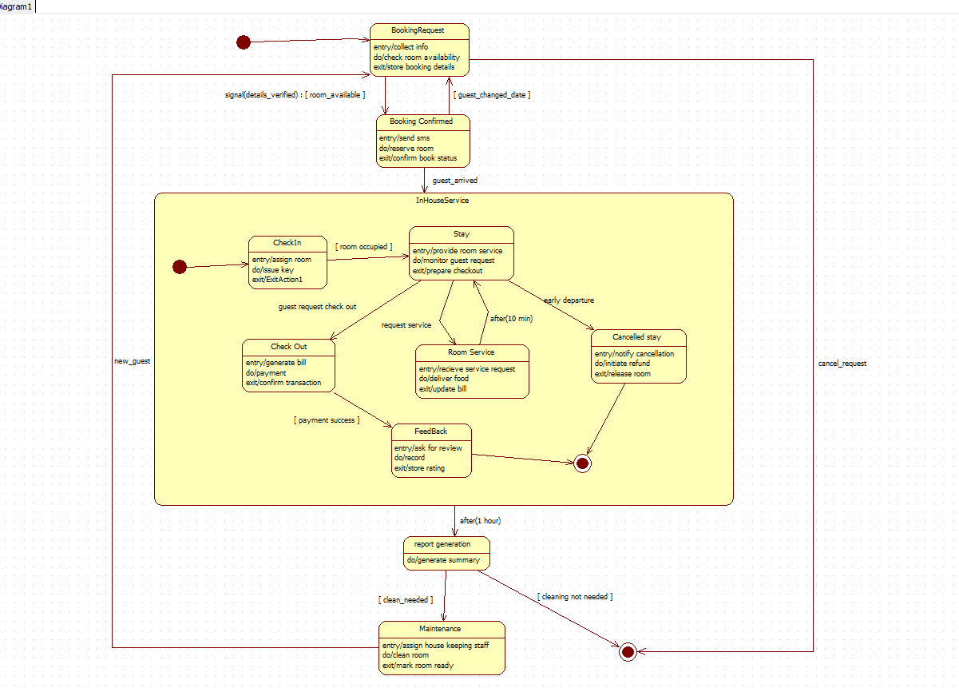
CREDIT CARD PROCESSING

